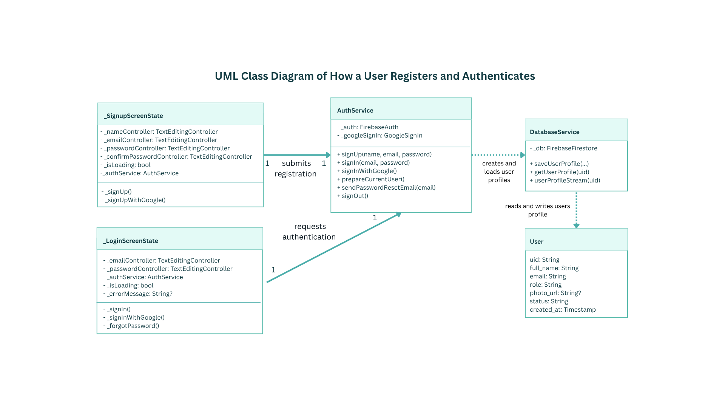
Figure 3.16. UML Class Diagram of How a User Registers and Authenticates
Figure 3.16 presents the classes involved in account registration and sign-in. The sign-up and login screen states call AuthService to handle email-and-password or Google authentication. AuthService works with DatabaseService to save or retrieve the account profile represented by the User document in Firestore, connecting the authentication flow with the user's stored account information.

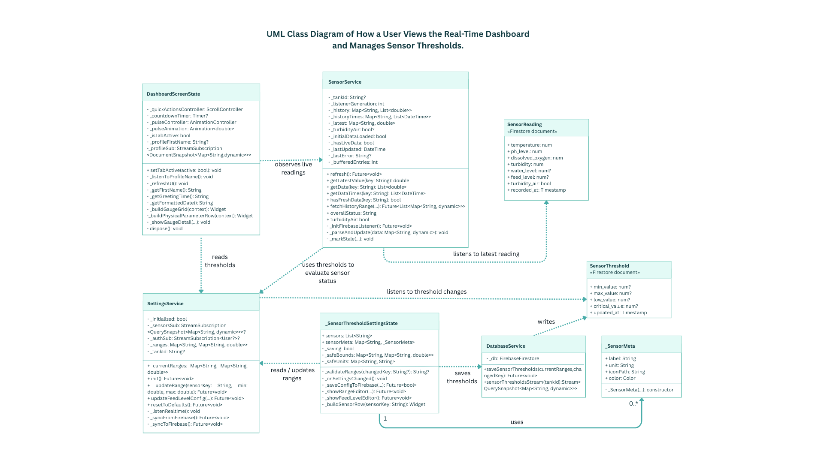
Figure 3.17. UML Class Diagram of How a User Views the Real-Time Dashboard and Manages Sensor Thresholds
Figure 3.17 shows DashboardScreenState receiving live sensor readings from SensorService. The threshold settings state uses SettingsService to load and update configured values, while DatabaseService persists them. Threshold fields depend on sensor type: water level uses low and critical values only, water-quality sensors use minimum and maximum values, and feed level is measured as a percentage with critical and low cutoffs.

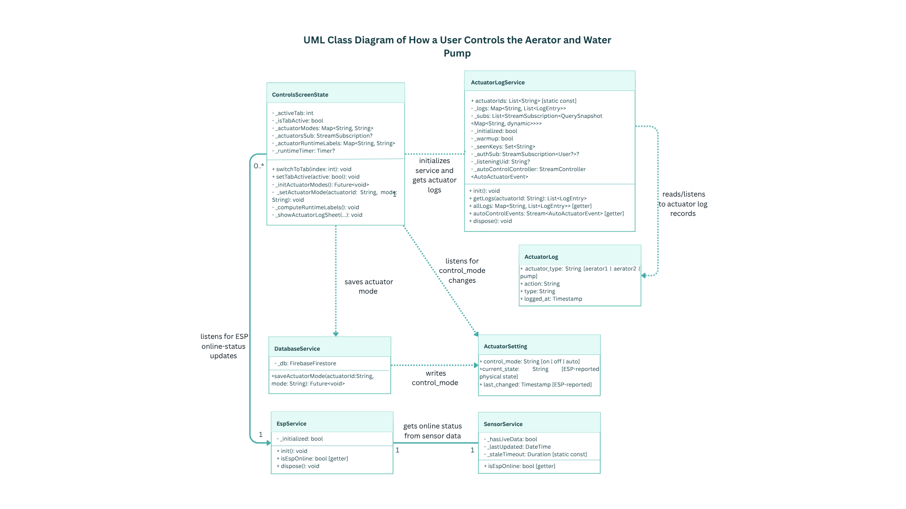
Figure 3.18. UML Class Diagram of How a User Controls the Aerator and Water Pump
Figure 3.18 shows how the Controls screen manages two aerators and the water pump. ControlsScreenState listens to each actuator's mode and lets the owner request On, Off, or Auto. DatabaseService writes the requested control_mode to the actuator document in the tank; the ESP applies it and reports the physical state. EspService exposes online status through SensorService. ActuatorLogService retrieves actuator logs for display and runtime calculations. A saved mode is a request, not confirmation that the hardware has changed state.
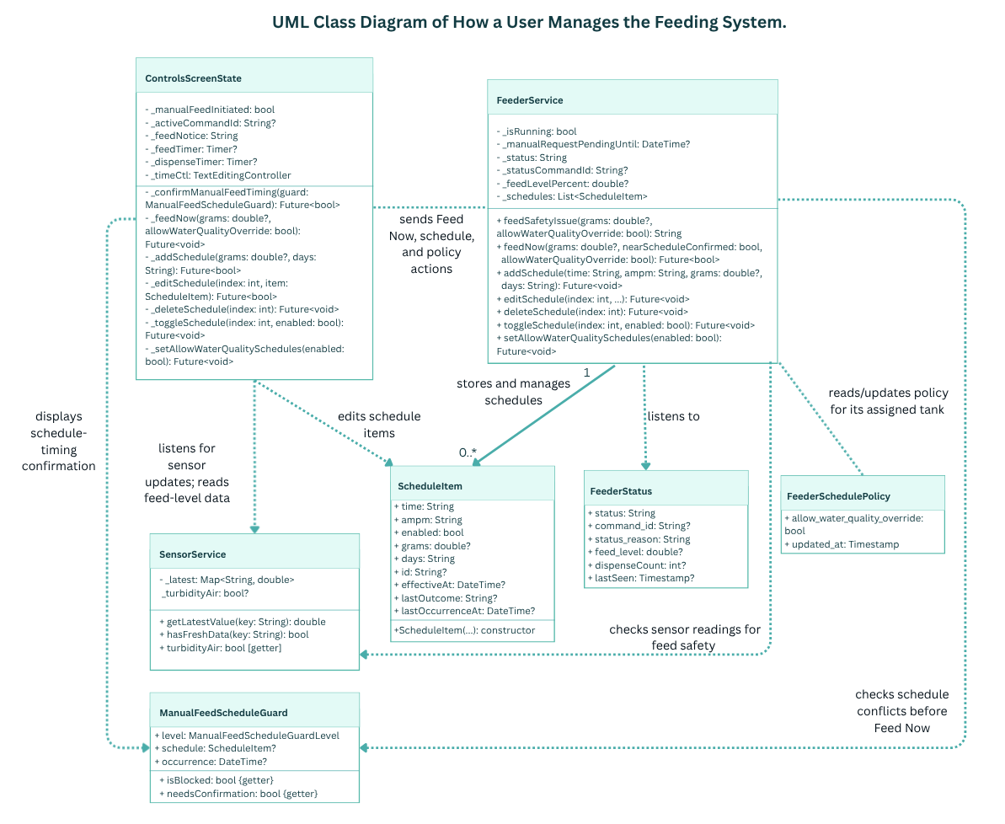
Figure 3.19. UML Class Diagram of How a User Manages the Feeding System
Figure 3.19 shows ControlsScreenState sending Feed Now and schedule requests to FeederService. FeederService checks sensor conditions through SensorService, manages ScheduleItem schedules, and reads the assigned tank’s FeederSchedulePolicy for scheduled water-quality overrides. Before a manual feed, ManualFeedScheduleGuard checks for nearby schedule conflicts and requests confirmation when needed. FeederStatus contains the reported command, status, feed level, dispense count, and last-seen time.

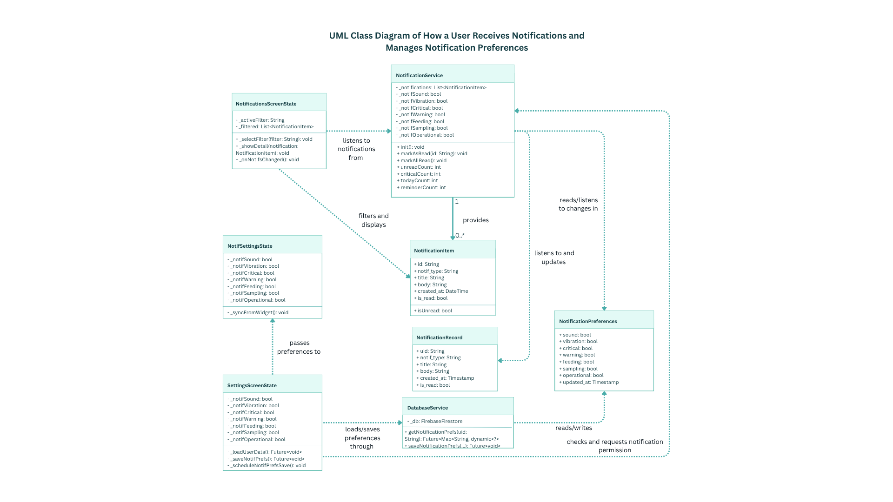
Figure 3.20. UML Class Diagram of How a User Receives Notifications and Manages Notification Preferences
Figure 3.20 shows NotificationsScreenState listening to NotificationService, which supplies notification items for filtering and display and updates their read status. SettingsScreenState passes preference changes through NotifSettingsState and uses DatabaseService to load or save the user's preferences. The diagram includes alert categories, feeding and sampling notifications, operational updates, sound, and vibration settings.

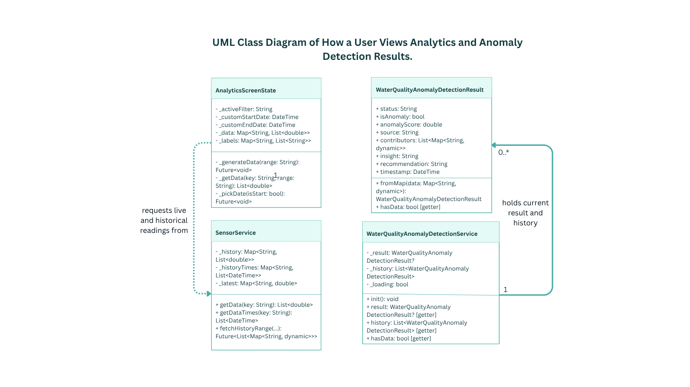
Figure 3.21. UML Class Diagram of How a User Views Analytics and Anomaly Detection Results
Figure 3.21 shows how the Analytics screen combines sensor-history charts with water-quality anomaly results. AnalyticsScreenState requests readings for the selected date range from SensorService and prepares chart values and time labels. Separately, WaterQualityAnomalyDetectionService listens to Firestore for the current result and recent history records, then maps each record to a WaterQualityAnomalyDetectionResult. The stored result includes its status, anomaly score, contributing sensor codes, insight, recommendation, source, and processing time; the app derives each sensor's display label from its code.

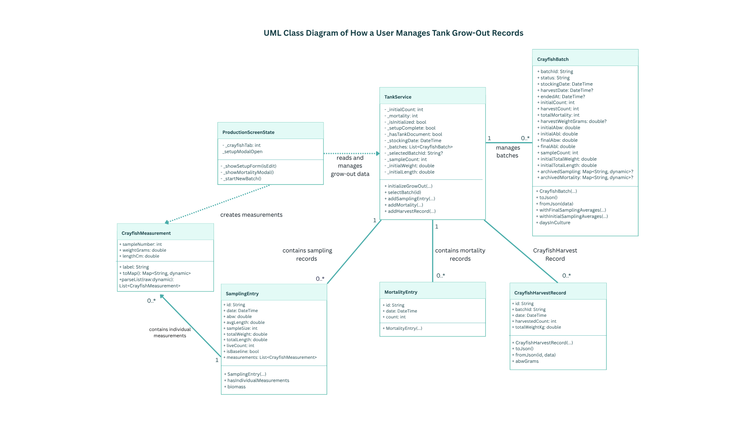
Figure 3.22. UML Class Diagram of How a User Manages Tank Grow-Out Records
Figure 3.22 shows ProductionScreenState working with TankService to initialize grow-out records, select a batch, and add sampling, mortality, or harvest entries. CrayfishBatch groups these records by batch. Each SamplingEntry contains dated CrayfishMeasurement records, and each measurement stores a sample number, weight, and length. Firestore stores the individual measurements; the app derives sample size, total weight and length, ABW, and ABL from them when reading the record. SamplingEntry exposes these aggregate values in memory, but they are not duplicated in the stored sampling document.

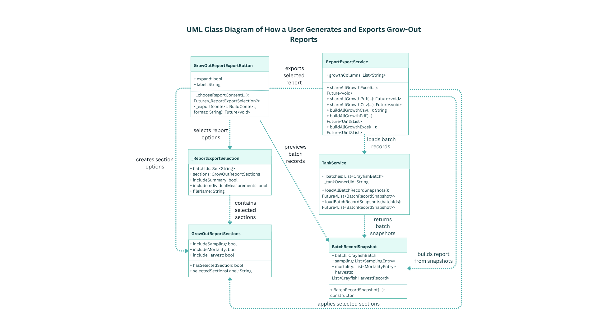
Figure 3.23. UML Class Diagram of How a User Generates and Exports Grow-Out Reports
Figure 3.23 shows the report-export flow. GrowOutReportExportButton gathers the format and report choices, while _ReportExportSelection holds the selected batch IDs, sections, summary and individual-measurement options, and file name. GrowOutReportSections specifies whether sampling, mortality, and harvest records are included. TankService supplies BatchRecordSnapshot data, and ReportExportService generates Excel or PDF reports that can include individual measurements. The user previews the selected report before confirming and sharing it.

